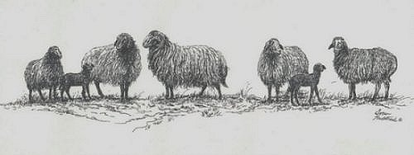
Provisional Registration Breed Standard Document

Date ___________________________
I have observed the following animal _______________________________________ that is
being considered for Provisional Registration. The ear tag and/or USDA numbers are
________________________. This animal conforms to the breed standard of perfection for the American Karakul sheep breed. Breed standards can be located on our website.

If there are any questions, please contact AKSR.

Signed _______________________________________ ID# __________________________
(This statement must be signed by a current member of AKSR, not the seller, the buyer or a member of the applicant’s family)

